November 24, 2020

Dear [Senator or Delegate X],

Thank you for your leadership during the General Assembly and Special Sessions in 2020. We are extremely proud of what was accomplished to protect Virginians during the pandemic, reimagine our criminal justice system, promote LGBTQ and women’s reproductive rights, and ensure access to voting.

There is still a lot of work to do and today we share with you our progressive goals for 2021. Since the upcoming General Assembly session will be short and focused, we have highlighted below some of the most important priorities that will ensure that we are working to make Virginia a safer, more inclusive, resilient, and environmentally healthy place to live for all of our residents.

We will follow up in January with a letter that identifies specific bills that we expect the Democratic majority to pass. We ask you to support them.

2021 LEGISLATIVE PRIORITIES

Promote fairness and transparency in our elections and politics
- Pass legislation to join the National Popular Vote Interstate Compact.
- Ensure a fair and transparent redistricting process. Transparency across the commission, special masters, and the court is necessary. Increase public hearings, including holding hearings after the maps are drawn.
- Establish campaign finance limitations including: overall limitations, banning contributions from public service corporations, and restrictions on personal use of contributions.
- Enact a process for campaign finance disclosure and transparency, including ethics reform, and passing a state resolution supporting overturning Citizens United.

Create environmentally healthy communities and protect against the impact of climate change
- Adopt advanced clean car standards to increase the availability of low and zero emission vehicles in the Commonwealth.
- Increase energy efficiency requirements in the Virginia building code for new home construction to meet national standards.
- Restore authority to the State Corporation Commission to cut rates unfairly charged by Dominion Energy and other utility monopolies and refund overcharges to Virginians.
- Return the power to the State Water Control Board to issue stop work instructions on natural gas pipelines.
- Restore full authority to the State Water Control Board to issue and revoke certificates under the 401 section of the Clean Water Act.

Make Virginia safer for all by reimagining the police and advancing gun violence prevention
- End qualified immunity.
- Institute automatic voter rights restoration for returning citizens convicted of felonies.
- Mirror Federal law regarding Domestic Violence Misdemeanors with respect to firearm possession.
- Ban the production of “ghost guns” that can evade background checks.

Promote equity and advance the rights of all Virginia residents
- Continue pursuing equal treatment policies for students based on sexual orientation and gender identity.
- Repeal provisions allowing adoption and child-placement agencies to refuse service based on religious objections against LGBTQ individuals.
- Pass a state constitutional amendment which guarantees bodily autonomy and protects the
right to make one’s own private, safe, legal choices on abortion established in Roe v. Wade.
- Implement a strategy to improve the education experience for Virginia’s secondary public school students and to narrow the inequity gap among schools.

Build resilient communities and support our workforce
- Provide broadband access for all Virginians.
- Create a community infrastructure fund to invest in local food systems across Virginia.
- Establish a statewide paid family and medical leave program.
- Require paid sick days for all workers, especially for “essential workers” who are often immigrants.
- Defend farmworkers by deleting the exemption of farmworkers under the minimum wage law, so that they are guaranteed a living wage. Oppose child labor in the fields.
- Strengthen opportunities for labor organizing and repeal the “Right to Work.”

We ask that you support these important legislative goals in the upcoming session.

The groups that endorse this letter are:

Virginia Grassroots Coalition
350 Alexandria
Our Revolution Alexandria
Postcards4VA
We of Action (WofA)
Lewinsville Faith in Action
Climate & Clean Energy Working Group, Virginia Grassroots Coalition
Vienna Neighbors United
Hunter Mill Huddle
Indivisible Arlington
Indivisible Virginia 11
Network NoVA
Virginia Chapter of American Promise
Indivisible Below the Beltway
Herndon Huddle
The Activated People
New River Valley Indivisible

Virginia Democracy Forward (VADF)
Indivisible Virginia
Protect Our Commonwealth
Virginia Justice Democrats
Arlington Young Democrats
NOVA Grassroots
Our Revolution Falls Church
Progressive Democrats of America - Virginia
350 Loudoun
WIN-NOVA (Welcoming Immigrant Neighbors)
Our Revolution Northern Virginia
Virginia Chapter, National Organization for Women (NOW)
Sister District DC/MD/VA
Indivisible Waterfront
Herndon-Reston Indivisible
NOVA Climate
Beyond Arlington
Green New Deal VA

 | 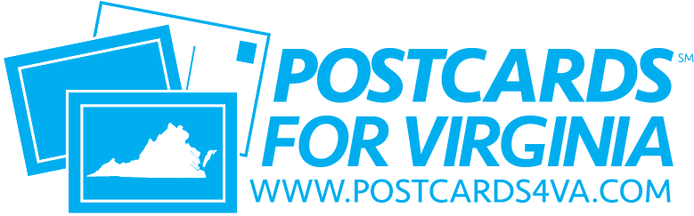 |  |  |  |  | 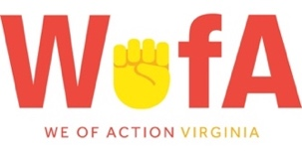 |  |  |  | 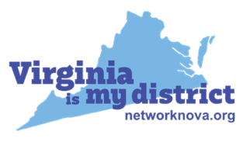
 |  |  |  |  | 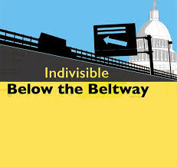 |  | 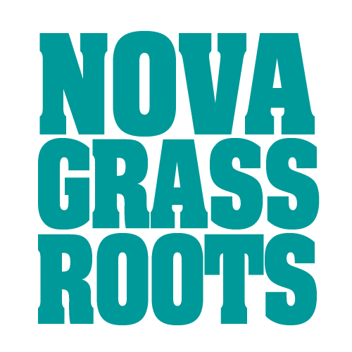 |  |  |  |  |  | Hunter Mill Huddle |  |  |  | 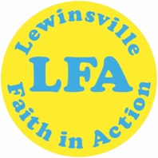
 | 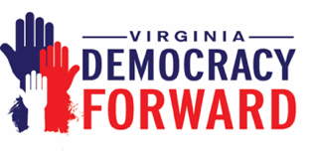 |  |  |  | 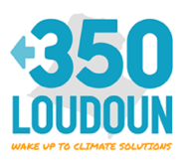 |  |  |  |  |  |  | 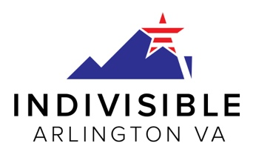 |  |  |  |  |  |  | 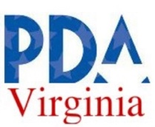
 | 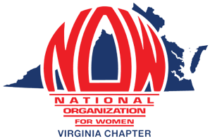 |  |  |  |  |  |  |  | 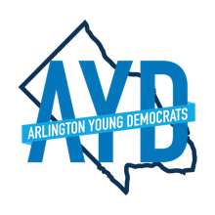 |  |  |  |  | 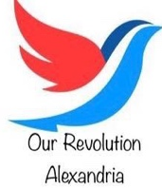 |  |  |  | 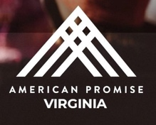
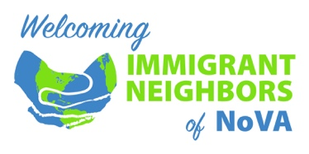 |  |  |  | 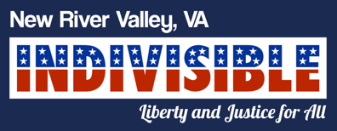 |  |  |  |  |  |  | 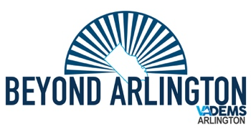 |  |  |  |  |  |  |  |  | 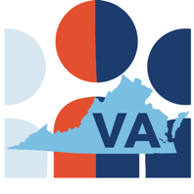
 |  |  |  |  |  |  |  |  | 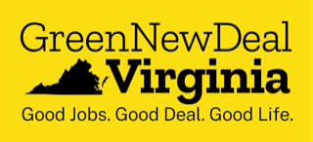 |  |  |  |  |  | 